A direct measurement of the speed of light in air

Tom Colbert
Department of Chemistry and Physics, Georgia Regents University, Augusta Georgia 30904

(Submitted January 29, 2015)

The speed of light is measured by time of flight in air using a Helium Neon Laser with wavelength 632.8nm. Laser light is split using a standard beam splitter with one beam sent to a trigger photodiode detector and another to a signal photodiode detector. The signal detector is moved a known distance and a corresponding time delay is measured using an oscilloscope. It is notable that the current method uses no additional means to generate a modulated laser signal. The generation of a rapid transient change in the intensity of the light signal is typically a challenge preventing this experiment from being performed easily in many elementary settings. The longitudinal modes of this laser beat together to generate intensity peaks which can be observed using simple detection equipment and commonly available oscilloscopes. Observations made by moving the signal detector over a total distance 2.00m in small increments yield a value for the speed of light in air of (2.994±0.032) x10⁸ m/s. The result is within approximately 0.10 of the uncertainty from the expected result after considering corrections for the speed from air to vacuum. The experiment is simple and can be performed in a small space quickly for demonstrations or lab activities.

I. INTRODUCTION

The speed of light in air is measured using time of flight by observing a repeated transient effect in the signal intensity of light from a HeNe laser. The signal is detected using a silicon diode detector which is moved in several steps over approximately a two meter range.
In typical physics course speed of light measurements, the laser signal is modulated either externally or a laser diode is modulated electronically.¹ In the present case, the signal modulation occurs naturally. The modulation is produced by the longitudinal mode structure of the laser. In HeNe Lasers it is typical for several longitudinal modes to be lasing at one time. The beats among the modes create a stable set of modulation peaks which can be tracked with high precision. Peaks in intensity are observed and used to track the motion of the signal detector and then determine the speed of light using an oscilloscope. The experiment is performed easily with relatively commonly available equipment. The method is approachable to all levels of physics students.
The fundamental frequency of the longitudinal mode for a typical laser cavity is c/2L where c is the speed of light in vacuum and L is the length of the laser cavity. In a typical HeNe laser it is expected that many modes satisfying the standing wave conditions (nc/2L) will be excited. The beat frequency between any neighboring modes is c/2L. The present experiment observes signal which predominantly shows a single beat signal with a period of roughly 2.00ns. The details of the Fourier spectrum of the signal are not important to the present experiment where all that is required is a stable and repeatable transient effect. However using the oscilloscope’s fast Fourier transform shows that the signal is dominated by the expected modulation at the fundamental frequency of the longitudinal mode. This and other HeNe lasers have produced such signal and allow for easy tracking of time that a transient signal reaches the signal detector.
The current method allows for simple measurements of position vs. time for a given peak in the laser intensity reaching the signal detector. The speed of light in air is then simply calculated.

II. EXPERIMENTAL PROCEDURE

The experimental setup is shown in Fig. 1. A sample of the laser signal intensity vs. time is shown in Fig. 2.

Silicon Photodiode
Oscilloscope signal and trigger
HeNe Laser
Beam Splitter
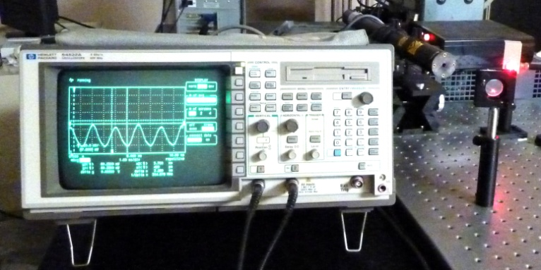

Fig. 1. Oscilloscope, Laser, beam splitter, and trigger photo diode are shown. The signal photodiode and two meter stick are not shown in the figure.

A Uniphase model 1145 laser was used, with output of 22.5 mW at a wavelength of 632.8nm. The longitudinal mode spacing is 257MHz and the tube length is 25 inches.²
An HP oscilloscope 54522A with 500MHz bandwidth and 1Gsample and Newport detectors 818-BB-21 with <1ns rise time and 10mA saturation signal were also used.
A beam splitter is used to send signal to both a trigger photodiode and signal photodiode. The trigger level is set to observe a modulation in the signal. Both the trigger and signal channels display very similar signal differing in amplitude due to where the detector is placed with respect to the transverse beam profile. The signal is similar to that shown in Fig. 2
Once a steady trigger signal is observed we observe the signal channel alone. Typically the signal detector is placed close to the beam splitter along a two meter stick fixed to the table. The oscilloscope cursor tools are used to measure the time on screen of a signal peak closest to the left edge of the screen. That marker time remains fixed throughout the data collection.
The spacing between consecutive peaks is approximately 2.00ns ±0.10ns. This agrees with the manufacturer published laser bandwidth expectation of 1.95ns. In order to ensure that we could track the time shift in the specific signal peak initially marked we made sure that the detector moves much less than the roughly 60.0cm which light travels in this time.
A second oscilloscope marker is used to measure the new time at which the detector receives the peak being tracked. As a check on the stability of the laser signal, data was taken each 20.0cm moving the detector away from the laser, and then back along the same path to recheck each position. The average time was used in each case. The observed repeatability in the data shows that the observed peaks remain stable and can be tracked.
The settings on the oscilloscope are typical to what is available in many undergraduate settings and are not of particular note. The termination on the oscilloscope should be set to 50Ω otherwise there may be loss of time response due to the RC time constant of the combined cable/oscilloscope system. The 50Ω termination matches the output impedance of the photodiode detectors used here. A typical run has settings for the oscilloscope at 20mV/division, 2.00ns/division, and uses averaging of 64. The settings may need modification from run to run or day to day due to alignment and signal stability.

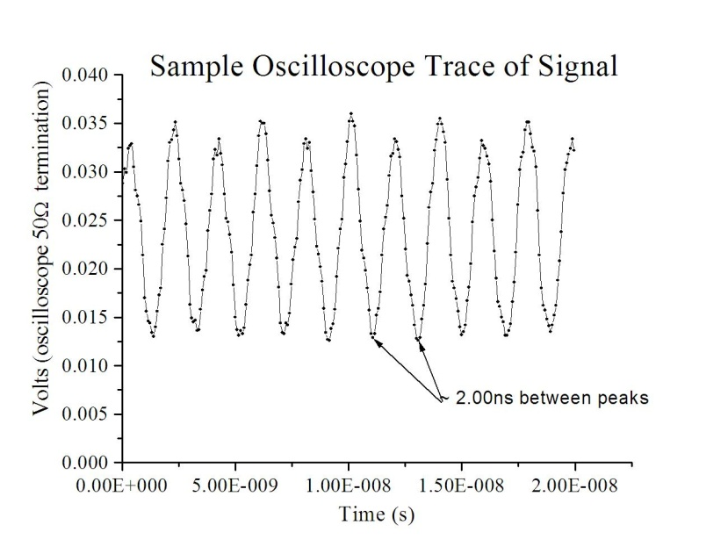
Fig. 2 Sample of data from oscilloscope trace. Peaks or dips are shown to be roughly the spacing expected due to longitudinal mode spacing of the laser.

III. RESULTS

The measured result using our data and a least square linear fit is: c=(2.994±0.032)x10⁸m/s, and is shown in Fig. 3. The difference found from considering the refractive index of air (n=1.0003) is not notable. The result agrees extremely well with the standard result.³
The uncertainty in reading and reproducing a peak time is estimated at 0.10ns and the uncertainty in reading detector positions is 0.005m. The detector position uncertainty can most likely reduced with careful measurement and use of an optical rail, however the impact on the uncertainty in the speed of light is mainly due to uncertainty in the peak time readings. A mode stabilized laser would most likely be required to improve the peak signal stability. The signal averaging on the oscilloscope allows the peak times to be determined with high precision.
The uncertainty cited for the determination of c derives from the statistical variation in the data only and is obtained from the curve fitting process. As a rough check we considered the maximum and minimum possible speeds of light using only the two endpoints of our data set. We took the difference and divided by two. As a further correction we divided by the square root of N where N is the number of data points used for our line fit. This gives appropriate scaling for the standard deviation in the mean for a set of data. The resulting approximate experimental uncertainty is 0.033x10⁸m/s, which is in very good agreement with results found using the linear fitting routine. The good agreement suggests that the approximate errors in our measurements are good estimates to the true deviations and that there are no substantial systematic errors.

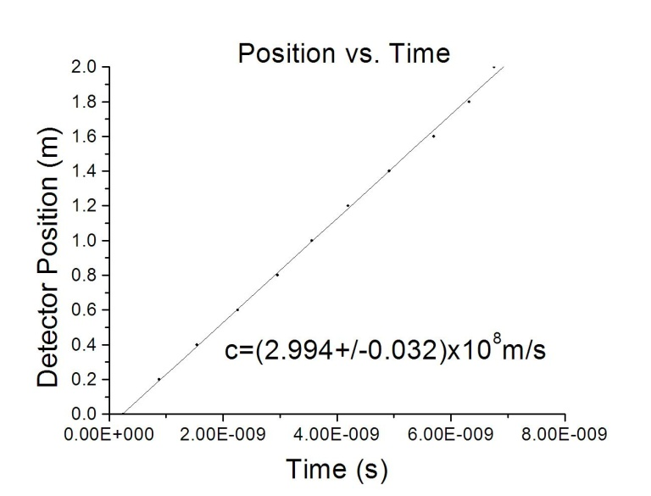
Fig. 3 Position vs. Time plot for the signal detector. The result using a least squares fit is shown on the figure. Error bars are not displayed but correspond to ±0.10ns and ±0.005m respectively for time and position.

IV. DISCUSSION

The experiment can be set up and performed on a table top with equipment which may be found in most undergraduate physics laboratories. Some care must be taken to ensure the use of a fast optical detector. Even the use of a laser with a shorter cavity (higher fundamental mode frequency---shorter time between peaks), and use of a slower oscilloscope should suffice. Such effects will reduce the observed intensity modulation depth, but the peak positions are still expected to be observable.
The mode spacing cited for this laser is 257MHz. This suggests that the amplitude of the light should vary with a time period of 3.89ns. However intensity variations should repeat with half that period, or 1.95ns. This is in very good agreement with the observed peak spacing of roughly 2.00ns. The figures are also in very good agreement with the laser specifications for the length of the laser cavity.
As an additional check a fast Fourier transform was performed on sample traces using routines in our HP 54522A oscilloscope. The frequency for the strongest mode is 257.5MHz, with other modes appearing in multiples of the fundamental. Such results are expected since several modes of excitation exist at once in a typical non--mode-stabilized HeNe laser.
The frequency spectrum analysis confirms the methodology used here and indicates yet another means of determining the speed of light by measuring the frequency spectrum.
The current results and experiment indicate a simplified method for measuring the speed of light. No external modulation system or electronics are required here. This method can work well with many gas laser systems, though it is expected that HeNe lasers are commonly available. There is no need to know the cavity length since the observer needs only to track any stable and repeatable transient variation in intensity.

¹Kenichiro Aoki and Takahisa Mitsui, “A tabletop experiment for the direct measurement of the speed of light”, Am. J. Phys. 76, 812-815,(2008).
²JDS Uniphase corp., “http://www.jdsu.com/
ProductLiterature/hnlh1100_ds_cl_ae.pdf”, (2010)
³Francis A. Jenkins and Harvey E. White, Fundamentals of Optics 4th Edition”, McGraw-Hill Primis Custom Publishing, (copyright 2001).

